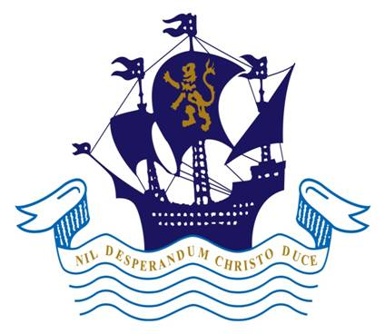
Childline:
0800 1111
The Children’s Rights Commissioner:
Maggie Atkinson 020 7783 8330
info.request@childrenscommissioner.gsi.gov.uk

Independent Listeners:
Nicola Mayhew 01473 659353
Paula Warner 01473 695231
Houseparents:
Mrs Stacey
Mrs Garbett

Boarding Staff:
Mr King
Mr & Mrs Matthews
Mr & Mrs Lawley
Mr & Mrs Middleton
Mr Taylor

Dorm Captains
Peer Listeners

School Nurse
Mrs Rawson

Head of Middle School:
Mrs Hunt
Deputy Head Pastoral:
Mr Hyatt

Headmaster or
Headmaster’s Wife:
Mr or Mrs Brown
Head of Boarding:
Miss Coventry
Your Tutor or any Teacher
Head of Boys’ Boarding:
Mr or Mrs O’Brien

WHO CAN I TALK TO IF I HAVE A PROBLEM?
Matrons:
Mrs Robertson
Mrs Dunlop
Mrs Nicolls
Remember you can also email: worry@orwellpark.org or use the worry boxes around the school.
Boarding Housemistress
Miss Coventry

