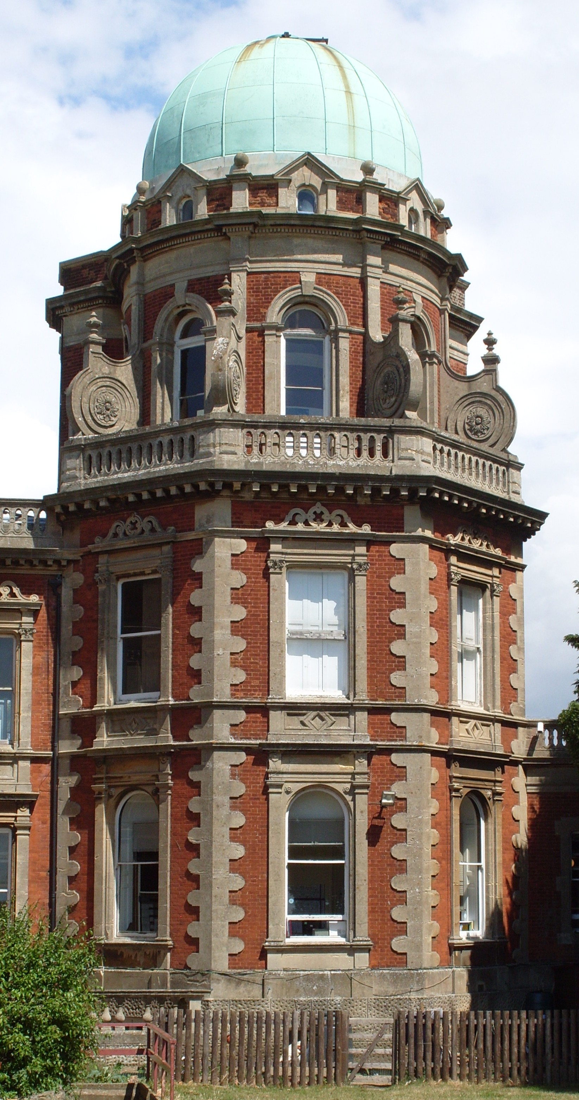
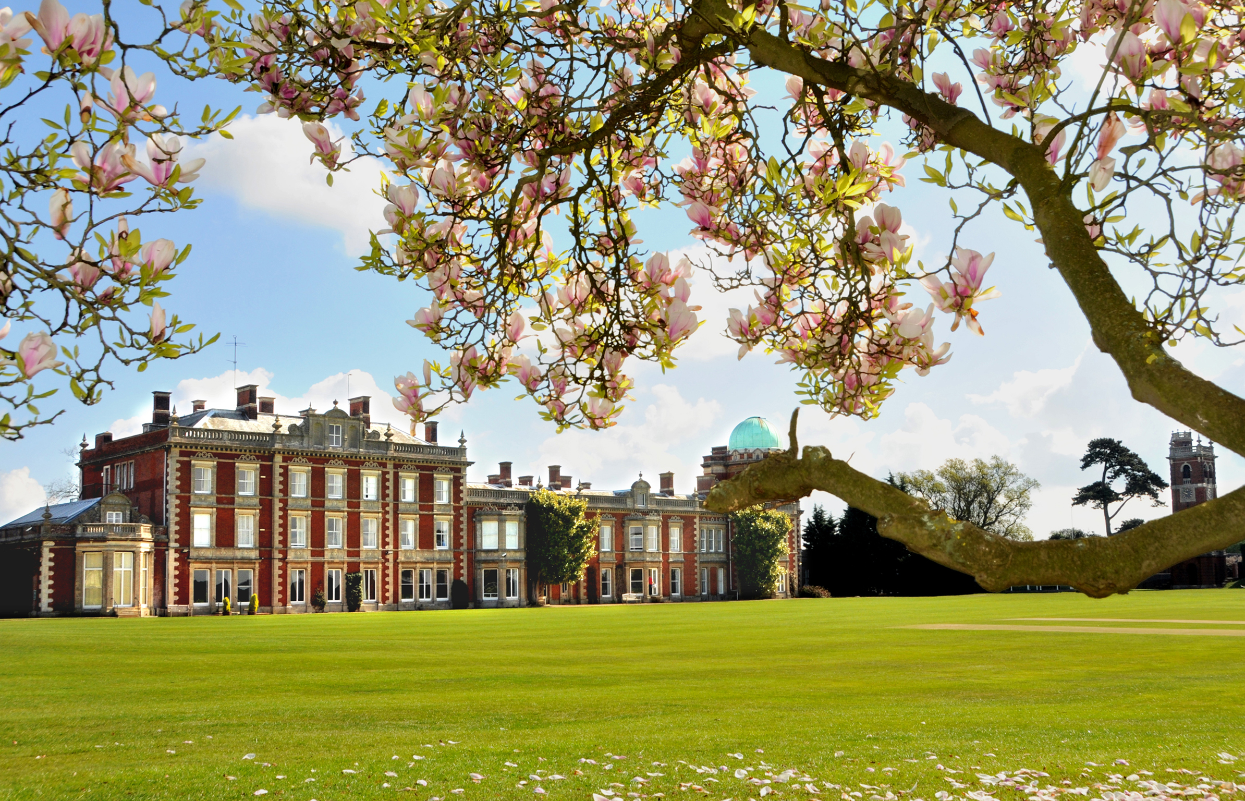
An extended tutor time will give pupils a chance to ask questions and prepare themselves for the day

They then start in normal lessons, following their timetable and shadowed by their guardian or another pupil depending on setting. Extra-English lessons will be timetabled and children are shown where to go.

Contact from the boarding house and tutors to parents is normally within the first 48 hours.
Pupils are encouraged to ask for help when they need it.

Useful email addresses:
jocoventry@orwellpark.org (Head of Boarding)
martinobrien@orwellpark.org(Head of Boys’ Boarding)
maryrawson@orwellpark.org (School Matron)
celiabush@orwellpark.org (EAL teacher)

DAY 3: SETTLING IN

Pupils are encouraged to call home in the evenings. They can use Skype or google hangouts on a Wednesday and Sunday evening in the boarding house. Email and letter writing is also encouraged.

COMMUNICATION HOME

OVERSEAS STUDENT INDUCTION PROGRAMME

ORWELL PARK SCHOOL
Morning:
Pupils will stay with their guardians for breakfast, both tutor times and assembly. They will receive and be talked through their timetable and a prep diary.
After tutor time, pupils will be taken up to see Matron to be sorted out with school uniform. When finished, they will spend time with The EAL teacher, Mrs Bush going through the school routine, having a tour of the school, and looking at some cultural differences that may be useful. This is a good opportunity to ask any questions.

Lunch will be with the pupils’ guardian, followed by a fire practice.

Afternoon:

In periods 7 and 8, they will set up their school email address and write home, sort out their library and computer access with Miss Coventry.

Evening:

After spending the rest of the day with their guardian, they will be brought up to the boarding house where they can phone home, relax and prepare for the next day.
Arrival:
Pupils are met by Boarding Staff who show them to their dorms and help them unpack. If pupils have come without their parents, there is a chance to call home to say they have arrived.

Non-European children will have visas and passports checked and photocopied on arrival.

All valuables are taken to the safe.

Evening:

A busy evening is planned for the pupils’ first night. Pupils first attend a welcome BBQ and may have a swim in school pool.
At this stage, the children will meet their guardians who will be responsible for helping them settle in and find their way around for the first few weeks.
After tea, there are pastoral workshops which are fun and a great way to meet some of the other children.

Pupils return to the boarding house to finish unpacking. They will be shown where to go if they are ill in the night, where the toilets are and what to do if there is a fire alarm in the night. They will be made to feel welcome by the other boarders! Lights out at normal times.

WEDNESDAY

THURSDAY

DAY 1: ARRIVAL

DAY 2: SCHOOL BEGINS

