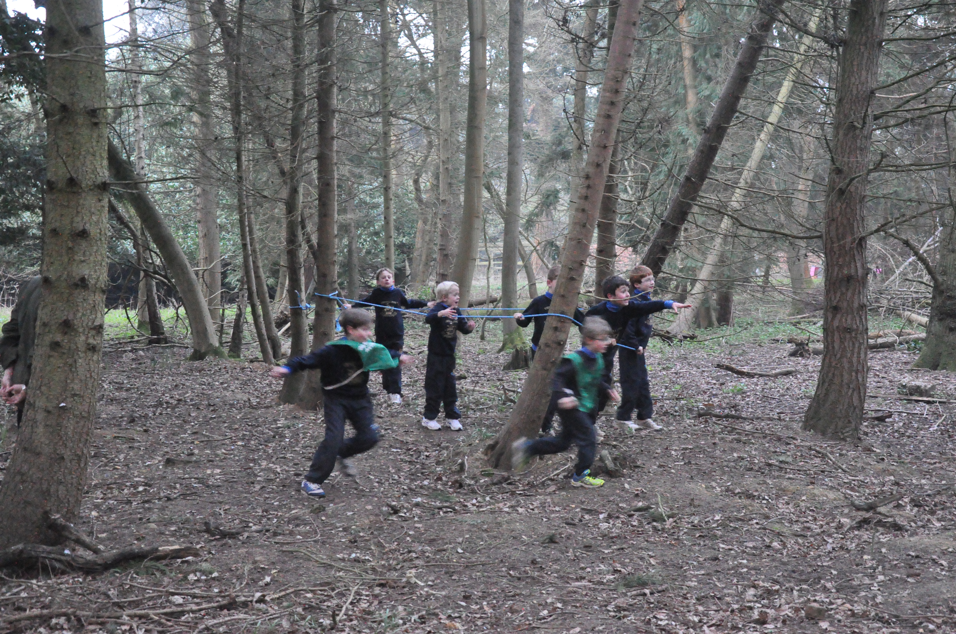
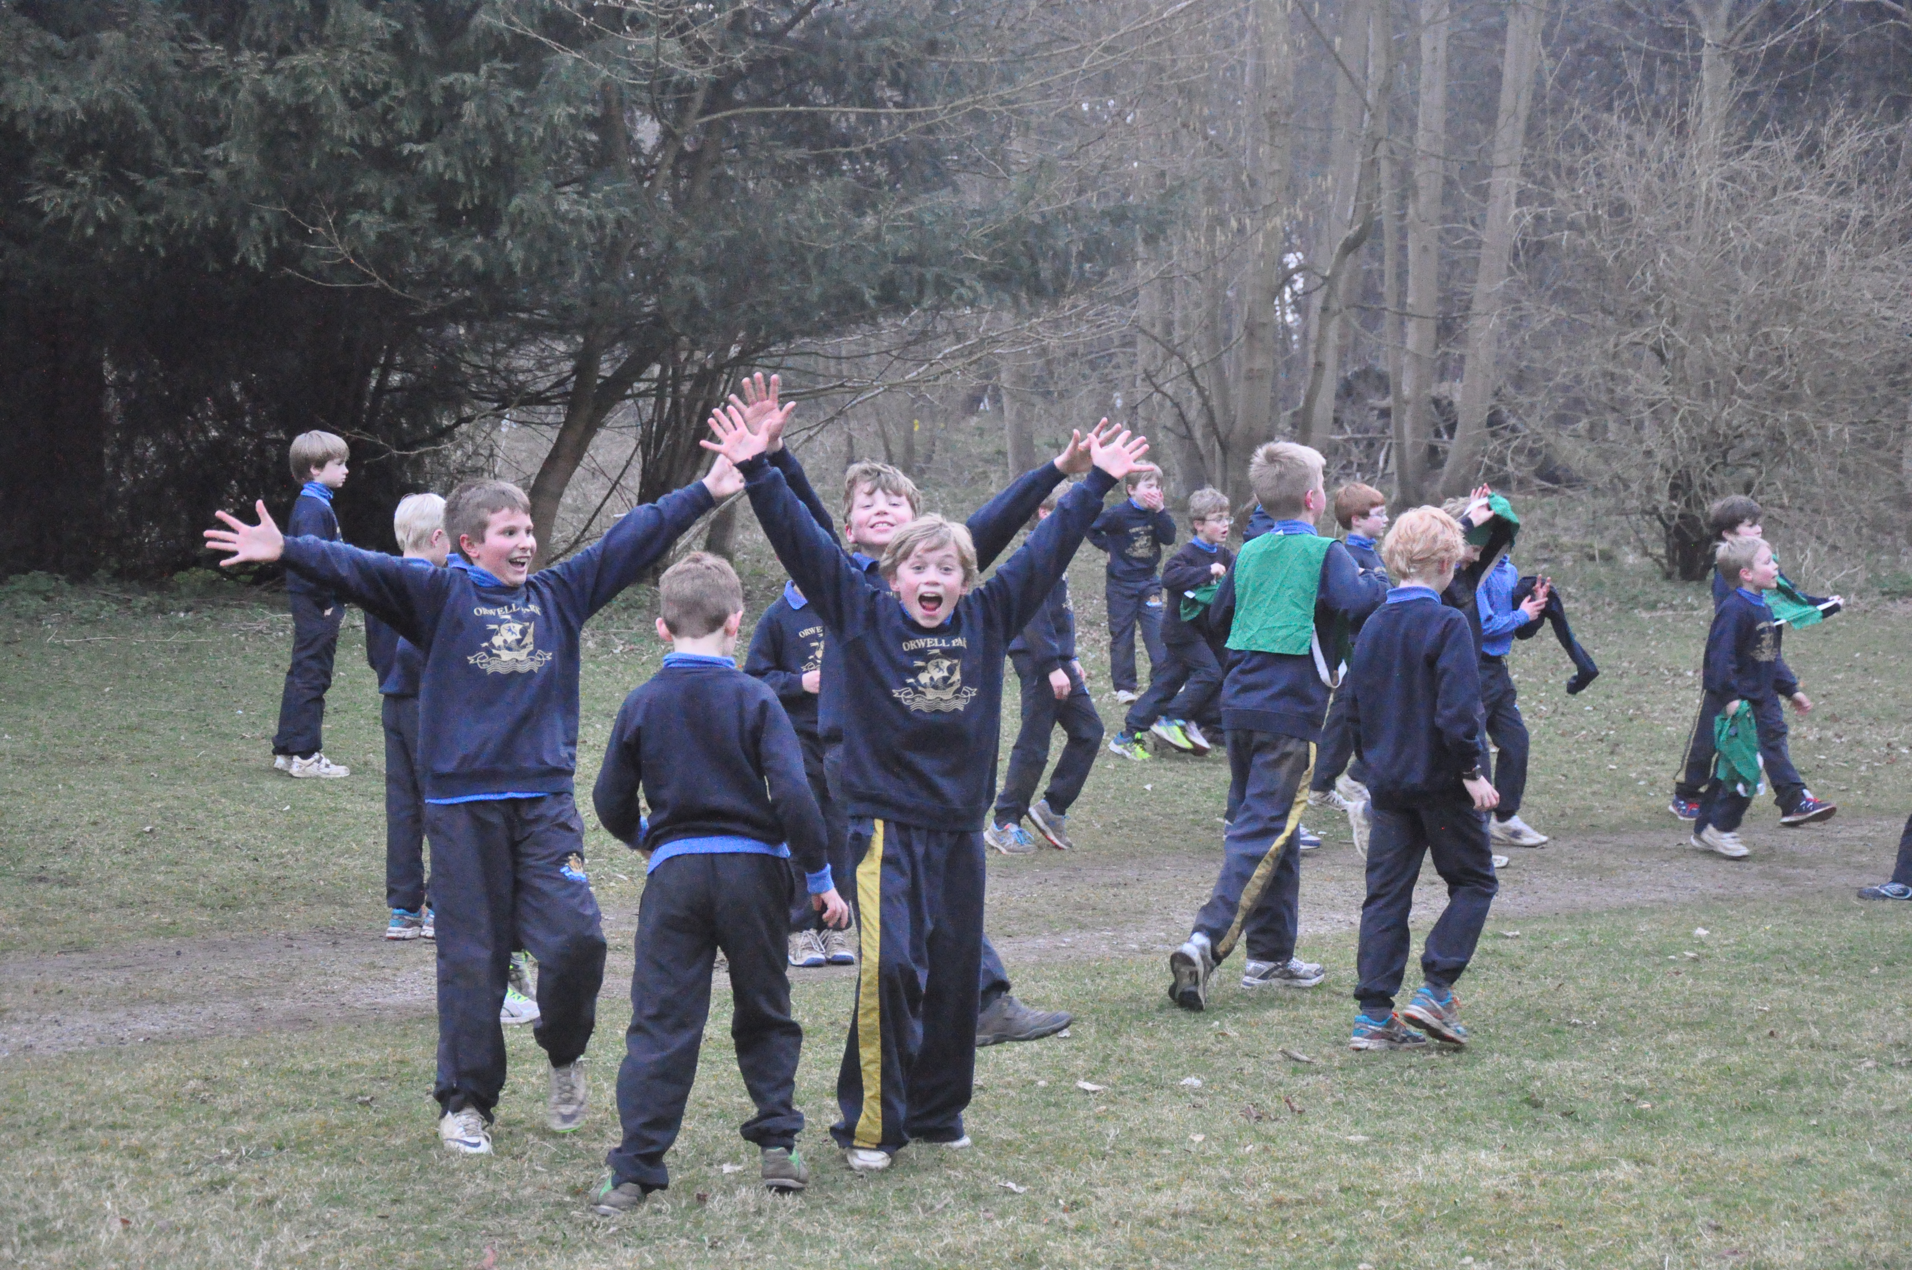
Mr Matthews is the Blueys’ leader. With many years experience of outdoor life he is looking forward to all the fun!
Mr King is the Blueys’ secretary and will be dealing with all the administrative side of the club. Please email him should you wish your child to join Blueys!
tristanking@orwellpark.org

This is an exciting new club created especially for boys in years 3-5.

The idea of the club is to be Orwell Park’s answer to Cubs! Pupils will have the opportunity to take part in a variety of activities and games that promote the outdoors, teamwork, leadership, creative thinking and independence whilst also having lots of fun!

Pupils are welcome to continue the fun in the boarding house afterwards. Please contact jocoventry@orwellpark.org to book a place. Non-boarders can be collected at 6.30pm from the North Hall.

Staffing

TUESDAY EVENINGS

5.15 – 6.30pm

As with Brownies for the girls, there will be a small cost each term of £20 which will be added to the school bill.

There will also be a Blueys’ hoodie which the boys will receive when they first join (at a one off cost of £20).

Cost

ORWELL BLUEYS

