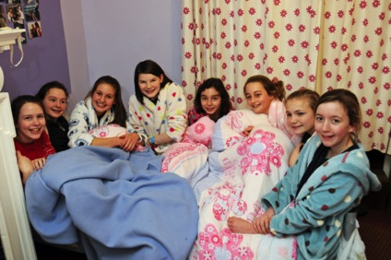
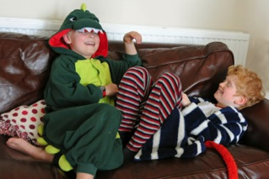
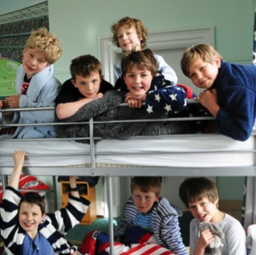
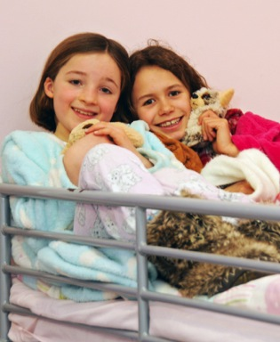
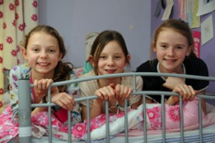


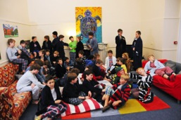
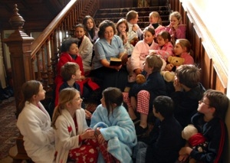
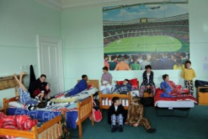
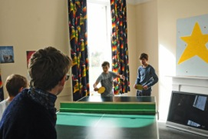
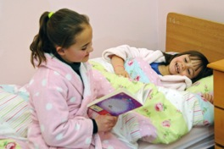
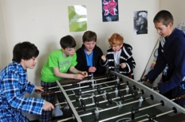
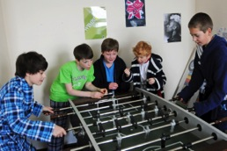
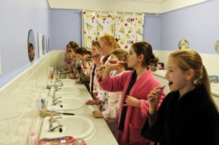
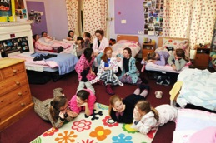
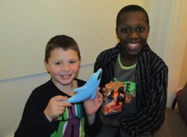
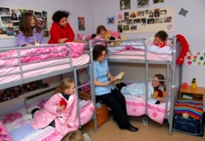

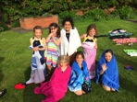
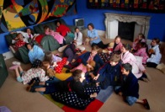
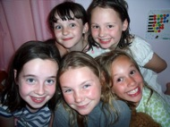
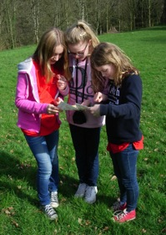

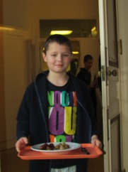
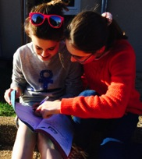
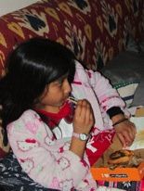
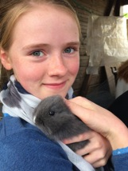
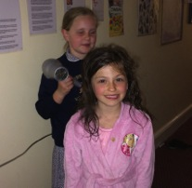
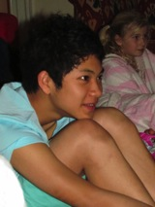
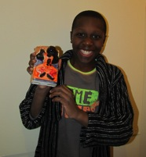
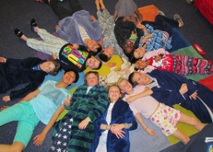
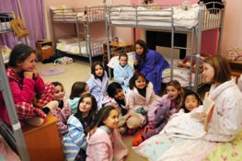
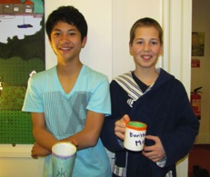
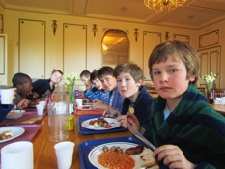
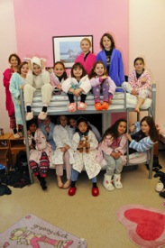
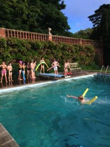

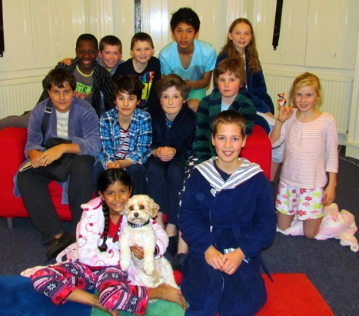
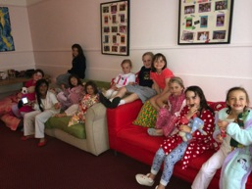

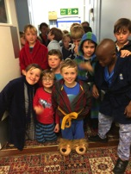

Welcome to Orwell Park’s Pupils’ Guide to Boarding.

Hopefully you will find all the information you need in here.

If you have any further questions, you can ask us when you see us, look at the school website or email jocoventry@orwellpark.org

(Head of Boarding)

martinobrien@orwellpark.org

(Head of Boys’ Boarding)
Year 4 boys
Year 4 girls
A Pupils’ Guide to Boarding at OPS
  - Year 8 girls
2014
  - Year 4 girls
  - Year 5 boys relaxing in the dorms.

OPSBOARDING

BOARDING
…helps in both the boys’ and girls’ boarding houses and with Middle School activities. She is married to Mr Middleton and lives on site!

Mrs Middleton
…works in the boys’ boarding house and helps Mr O’Brien in making sure you enjoy your boarding experience! Mr King helps out at weekends too, taking boarders on exciting trips such as bowling, cinema, shopping and trips to the seaside! Mr King is Head of RS and loves to sing!

Mr King
…loves boarding! He is in charge of activities and is happy to listen to your ideas about what you would like to do in the evenings. (*See activities page). He is also Head of Design Technology and loves to do DIY! Ask him about canoeing trips in the Summer term!

Mr Matthews
…joins in the fun in the girls’ boarding house on Friday evenings. She has twin boys who are in the Pre-prep and is married to Mr Matthews. They live on site.
…works at Reception and is in charge of the fun on Wednesday nights! She is married to Mr Lawley who works in the boys’ boarding house.

Mrs Matthews
…works in the girls’ boarding house and takes activities too. She in charge of tuck on Thursday evenings and works weekends to help the full boarders have a great time!
…is Head of Boys’ Boarding. He is in charge of all the boys, organising your dormitory placements, looking after you in the boarding house and helping you when you need it! Mr O’Brien is also Director of Music, putting on lots of concerts at the school throughout the year.

Mr O’Brien
…is Head of Boarding. This means she oversees all of the boarding at the school to make sure that you feel safe, happy and well-cared for. She is also a French teacher and does lots of hockey, netball and rounders too!

Miss Bugg

Mrs Lawley

Miss Coventry

The boarding houses are split into two areas: on the first floor you have the boys’ area and on the second floor you have the girls’ area.

THE STAFF

Here are the boarding staff who will look after you:
Matrons are wonderful people who help you in a variety of ways.

- Looking after you if you feel unwell or upset
- Organising your belongings
- Washing your clothes and games kit in particular
- Looking after you in the evenings and weekends
- Organising visits to the doctors or dentists if necessary
- Being a friendly face to turn to with any problems.

Useful emails:

Miss Coventry

jocoventry@orwellpark.org

Mr O’Brien

martinobrien@orwellpark.org

Matrons

matron@orwellpark.org

Laundry

laundry@orwellpark.org

We have a really useful email address at school:

worry@orwellpark.org

This is set up in case you have a worry but are finding it difficult to talk directly to someone about it. Sometimes writing things down really helps and we can then help you with your worry.
…works in the boys’ boarding house. He is also Head of English. He loves taking activities and also directs school plays, which are always great fun!
…also works in the boys’ boarding house. He is Head of Maths and lives on site. He loves his sport and particularly sailing. He organises many trips for pupils who are interested.

THE MATRONS

Mr Middleton
…works in the boys’ boarding house. He works in the sports’ department and loves hockey in particular but can talk for hours about all sports!

Mr Lawley

Mr Taylor

THE ROUTINE

Year 5 and 6 Boarders

Grub takes place at 7.30pm for Years 3-6. There is toast and spreads, cereals, fruit, milk, squash and water to make sure you are never hungry after a busy day of working hard and running around!

Grub

Once the school day has finished (at 5pm) there is lots on to entertain you! There are different timetables for different age groups. Have a look to see what you will be doing.
5.15 – 6pm | Activities or Prep for Year 5  Prep for Year 6
6 – 6.45pm | Tea and free time
6.45pm | Registration in the Orangery
7pm | Activities
7.30pm | Grub, then up to the Boarding House  Shower and change  Free time in the Common Room
8.30pm | Reading Time
8.45pm | Lights Out

Year 3 and 4 Boarders

5.15 – 5.45pm | Tea
5.45 – 6.40pm | Activities
6.45pm | Registration in the Orangery
7pm | Go up to the Boarding House  Shower and change  Free time in the Common Room  Grub  Story Time
8pm | Lights Out

Older children (Year 7s and 8s) start to have more prep, a later bedtime and a longer activity slot. There is also ‘House Time’, where you can come up to the boarding houses early to relax after a long, busy day – although most choose to get stuck in with activities!
Before lights out, you are reminded to go to the loo, wash your teeth and get some water, if you would like some.
This means that once lights are out and you have finished reading time, you are ready to settle down to some quality sleep. We are very strict on bedtime as you need to be fresh and ready for all you have to do the following day!
If you feel ill in the night, you should ask your Dorm Captain to take you to see Matron who is always available!

AFTER LIGHTS OUT!

THE ROUTINE

Year 7 and 8 Boarders

5.15 – 6.15pm | Prep
6.15 – 6.45pm | Tea and Free time
6.45pm | Registration in the Orangery
7pm | Activities
7.50pm | Grub
8pm | Go up to the Boarding House  Shower and change  Free time in the Common Room
9pm | Reading Time
9.15pm | Lights Out

Dry slope skiing
Computers
DT
Swimming

Drama games
Ballet
Cookery
Ceramics
Table tennise
Squash and badminton
Nets

Karaoke
Board games
Chess
Pistol shooting
Campfires
Netball
School Discos
Rounders
Textiles
Tray jousting
Football league
Manhunt
Housetime
Sewing
Canoeing
Karate
Orienteering
Film night
Play rehearsals
Dodgeball
Art
Orangery Lectures
Cricket
Sailing
Tennis

There are so many wonderful activities that you can do at Orwell Park. Have a look at this list to see some of the options available.

EVENING ACTIVITIES
Your Peer Guardian will contact you in advance of arriving at Orwell Park. Feel free to write back to them (by email or letter) and ask them any questions that you may have!
When you first arrive at Orwell Park, you will be given one or two other children in your year group who will look after you and help you to settle in.

Normally, these children are in your tutor group, dormitory or several of your subject sets.

They will help you with the following and should achieve these tasks within the first few days:

- Show you around the school.
- Show you where the loos are.
- Show you what to do if you feel ill and where Matron will be.
- Introduce you to your tutor, other children in the year group and other important people that you should know about!
- Help you to set up your library pass and computer passwords etc.
- Teach you some of the Orwell Park routines!

Hopefully, you will settle in really well and fairly quickly but it is always nice to have a friend to turn to in those first few weeks.

PEER GUARDIANS
Bullying | Bullying is the intentional, repetitive or persistent hurting of one person by another. We do not accept bullying behaviour in any form and it is treated very seriously. Measures are put in place to help individuals deal with these situations in a positive way. Should you feel you are being bullied, you should seek help from a member of staff straightaway.

Boarding  Assemblies | These happen at 7.50am on a Saturday morning in the Orangery. All pupils that board on any night of the week should attend.
Boarding Points | These are given out to pupils for good behaviour and helpfulness around the boarding house. At the end of each term, the children with the most boarding points (BPs) win a prize – normally a trip to Pizza Hut or a pool party in the summer!

THE A-Z of BOARDING AT ORWELL PARK
Activities | Every evening, there is a good selection of activities on offer. After registration at 6.45pm, you can choose which activity you would like to do.
Bathrooms | There are main shower and washbasin areas for you to use and plenty of toilets around the boarding house. You will be shown these on your arrival.
Boarders’ Forum | This is attended by a couple of boarders from each year group two or three times a year. With the boarding staff, we discuss things that you would like to change or improve and come up with new ideas for the boarding houses.
Boarder of the Week | This award is given out weekly (in the Boarding Assembly) to one boy and one girl. It is normally given to someone that has behaved brilliantly or been particularly helpful.

Discos | We normally have a School Disco each term. They are great fun and the music and themes are often chosen by the Dorm Captains or School Council.
Dormitories | You will be given a dormitory when you first arrive and a bed with your name on. This remains the same for the whole term. There is an opportunity at the end of each term to fill in a Dorm Request form which gives you a chance to state your preferences.

THE A-Z of BOARDING AT ORWELL PARK
Common Rooms | Both the boys and girls have lovely Common Rooms where they can relax in the evenings. There are television and computer games but also books and board games to entertain you.
Communication Home | Pay-phones are available for calls when necessary in both boarding houses.  Letters from family and friends are delivered to the school most days. Tutor time is a good opportunity for you to write letters back!  Emailing is also a popular way to keep in contact with home and friends. Every child has the opportunity to have an email address and this can be set up when you first arrive at school. Mr or Mrs Beck are the people to see! This is something your peer guardian can help you to do.  For Full Boarders, Mobile phones are allowed and they can also use Skype and google hangout to keep in touch.  Ask about these things if you are unsure!

THE A-Z of BOARDING AT ORWELL PARK
Dormitory  Captains | In each dorm there is a Dorm Captain. They are Year 8 children who help look after you and sleep in your dorm.
Duties | There are a few duties for senior pupils but everyone is expected to contribute to keeping the boarding house a pleasant place to live!
Electrical equipment | There should be no electrical items in school unless you are a full boarder. These items should be kept in the school safe until the weekends when you may have them.
End of Term | At the end of term it is important that you leave your area tidy. You should make sure that you have taken everything home. If you are an overseas boarder we can store some of your possessions for you over the holidays. You should speak to the Matrons or boarding staff to see what to do.
E-safety | If you have any concerns online, there are several things that you can do: speak to a member of staff; report your problem to CEOP (you will see a safety button on your website). There is also a whole section on e-safety on the OPS links page.
Fire Alarm | If the fire alarm goes off:  You should:  * get up, put on your dressing gown and slippers  * follow your dorm captain down your fire route, walking and IN SILENCE  * wait in silence at the assembly point whilst you are being registered. You are NOT to talk and must remain in position until told what to do by a member of staff.  The place of assembly is outside the orangery. You will be shown this on the first day of term.

THE A-Z of BOARDING AT ORWELL PARK
Fire prevention | It is strictly forbidden to use any products such as matches, lighters, candles, incense sticks or aromatherapy burners in school, which all involve naked flames, because of the potential danger of fire. Aerosols deodorants are also not allowed.
Going out with others | If you are a Full Boarder and wish to go out with a friend from school at weekends, the arrangements must be confirmed in advance, preferably by the previous Wednesday with Miss Coventry or Mr O’Brien. Your parents and the hosting parents need to give permission. Email is often the best way to do this.
Health | - If you feel unwell, you should tell the member of staff or matron on duty.  - After lights out, you should wake up your Dorm Captain and ask to be taken to Matron.  - If you have any form of medication this has to be handed straight to the Matron on arrival.  - If you are unable to take part in games sessions, you should get permission from Matron to be ‘off games’.
Independent Listeners | We are lucky to have two Independent Listeners who know the school but do not work at Orwell Park. They are happy to see children who have a worry and don’t want to talk to anyone at school.  They are: Geoffrey Grant, the vicar at Nacton Church, Paula Warner, who runs the local shop and Nicola Mayhew, a former parent.
Laundry | There is a laundry basket for your clothes every evening. You may put your clothes in there to be washed as often as you like. If you are a full boarder, you will be reminded when you must put your clothes in. Flexi-boarders often take their clothes home but either option is fine. If putting clothes in the laundry basket, they must be NAMED!  Your beds are changed regularly. The School provides bedding for you but you are also allowed to bring in your own bedding, providing it is clearly named.

THE A-Z of BOARDING AT ORWELL PARK
Mobile Phones | Mobile phones are not allowed unless you are an Overseas Boarder or have a special reason and permission from the Head of Boarding.  Mobile phones are kept safely during the day in the Boarding Office (for the boys) and in the girls’ safe (for the girls). They may be retrieved in the evening for sensible use.  You are reminded that your phone should only be used for phone calls or texting home and mustn’t be used for photographs, internet or filming in the boarding house.
Morning Routine | 7am Wake-up  7.20am Breakfast  8.05am School Starts
Naming | ALL of your items need to be clearly named using sew-on labels for clothing. Please provide spare nametapes to the Matrons when you arrive so they can be used as required.
Newspapers | Several newspapers are available in the library to read. We also have magazines in the boarding houses.
Packing | Suitcases used for packing are stored by the Matrons and can be retrieved for Half Terms or Long Weekends as necessary.

Meals | All meals are taken in the school Dining Room under supervision.  Breakfast is between 7.20am and 7.50am; lunch between 12.40pm and 1.30pm and supper between 5pm and 6.40pm. There are certain set times for your year groups for lunch which you will be told about by your teachers.

THE A-Z of BOARDING AT ORWELL PARK
Passports and tickets | For Overseas Boarders, passports and tickets should be handed to the Boarding Staff on arrival and these will be kept in the School Safe for security reasons. Children from outside the EU must always keep their passports at school during term time.
Peer Listeners | These are senior pupils who have been trained to help you deal with problems or concerns you may have. They can help you with smaller problems and will offer suggestions. With larger problems, they will accompany you to see a member of staff or an Independent Listener.
Pocket money | Full Boarders, who stay in at weekends, will need pocket money for trips and activities. Pocket money should be handed to the Boarding staff on arrival and will be kept in the school safe. Pupils can then ask for this money when required.
Positions of  Responsibility | There are several positions available for boarding pupils. In Year 8, you can be a Dorm Captain, Peer Listener as well as a School Prefect or Captain of your sports team. We also have two Head Boarders (one boy, one girl).  For all year groups, you can be a member of the Boarding Forum or School Council where you have the opportunity to represent your peers and express opinions about the School and Boarding, providing new ideas for improvements.
Posters | You are welcome to bring in posters and photographs to stick up around your bed to help make your dorm feel homely. In fact, we encourage you to!

THE A-Z of BOARDING AT ORWELL PARK
Signing – in and out | If you are a Flexi-Boarder, you must sign out every time you leave school. If you are late in the morning, you must also sign in if you have missed registration.  If you are unable to board on an evening when you would normally board, your parents should let the Head of Boarding or Head of Boys’ boarding know in advance.
Tuck | Tuck is a treat that boarders receive in the evenings on one or two nights a week and at weekends. No other sweets or the like should be brought into school.
Uniform | You should aim to keep your uniform looking clean and tidy. You are expected to have your shirt tucked in and shoelaces done up! Any problems that you have with your uniform, you can find Matron for some help!  We also have a best uniform at Orwell Park for special occasions. ‘Number 1s’ are kept with Matron and collected by you when you need them (concerts, visits to other schools etc).
Worries and Problems | It is quite normal to have worries or concerns at some stage during your schooling. There are plenty of people here that are happy to help you try and sort things out.  You can ask for help from the Boarding Staff, Matrons, Tutors, the Headmaster and his wife (Mr and Mrs Brown), Dorm Captains, Peer Listeners or any member of staff.  You can put a letter or note in the worry boxes around the School or write an email to worry@orwellpark.org which will be picked up by the Deputy Head Pastoral (Mr Hyatt).

Bowling
Go Ape
Saturday night tends to be a more relaxing evening with a variety of things to do such as a trip to the shops and a film, ceramic decorating, fish and chips in a local village, a swim or a walk along the seafront!
On Sundays, the boarders often explore the local area, visiting interesting towns and villages or the seaside. They often take part in a variety of activities such as golf, bowling, swimming, sailing, boating, cooking, go-ape, climbing, shopping, outdoor markets and fetes and many more!
Train trip to North Norfolk
Tennis
Bury St Edmund’s Christmas Market
Crabbing at Waldringfield
Pleasurewood Hills
Sardines and paper airplane competitions!
Shopping at Bluewater or Braintree
Cook your own meal
Cricket and rounders
Poolside BBQ
Cinema
Golf
Visit to Duxford Air Museum
Sailing at Alton Water
Swimming at Felixstowe Leisure Centre
Fish and Chips at Aldburgh
Boating on Thorpeness Mere
The School is open every weekend apart from Long Weekends and Half Term Holidays. We have several children who stay in and enjoy the huge range of activities on offer.

WHAT HAPPENS AT THE WEEKENDS?
- I WILL BE POLITE, KIND AND HELPFUL TO EVERYONE

- I WILL BE TOLERANT AND CONSIDERATE OF OTHERS

- I WILL RESPECT THE PROPERTY OF OTHERS’ AND THE SCHOOL

- I WILL LISTEN TO THE BOARDING STAFF AND MATRONS

- I WILL BE QUIET DURING READING TIME AND LIGHTS OUT

- I WILL KEEP MY DORM AND MYSELF CLEAN AND TIDY
Do get in touch before you arrive and ask any questions you may have!
jocoventry@orwellpark.org or martinobrien@orwellpark.org
Otherwise, we look forward to seeing you soon!

In the boarding houses, we have six simple rules that we ask all pupils to follow so that we can live together harmoniously! Have a look at those rules below!

The GOLDEN RULES OF BOARDING AT ORWELL PARK

