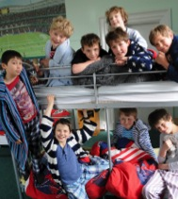
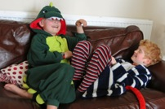
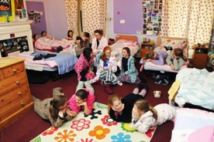


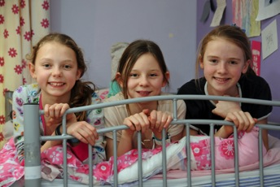
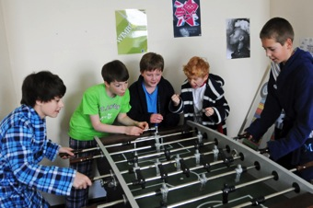
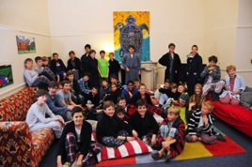
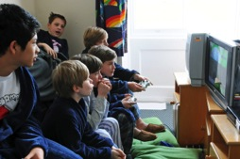
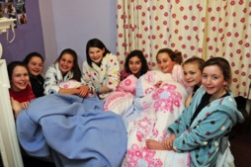
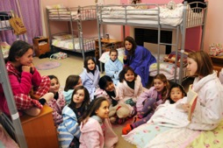
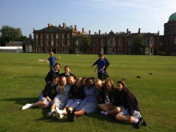


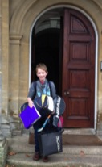
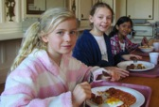

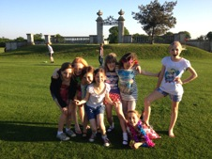
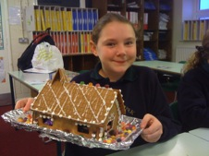

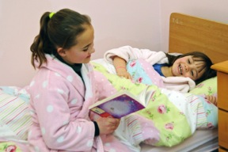
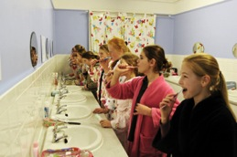
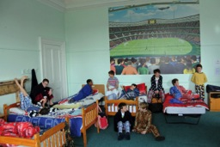
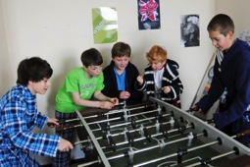
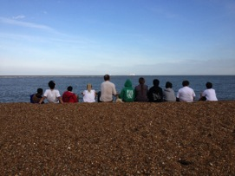

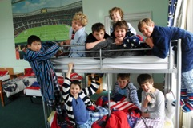
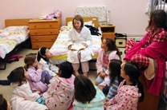



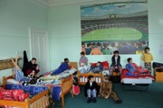
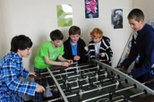
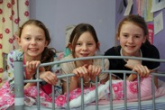
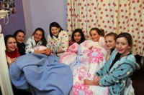
P2 Boarding Staff
P3 What to Bring
P4 Evening Routine
P5 Weekend Boarding
P6 Other Useful Information
P7 Expected Behaviour, Rewards and Sanctions
P8 Activities
P9 Why board?
P10 Sleep and Other Info!

We have several different types of boarding at Orwell Park! There are three main types:

Full (Seven days a week)
Weekly (four or five nights a week)
Flexi (from 1-3 nights a week)

At the end of the previous term, a letter is sent to all parents asking if you would like your child to board. You then need to fill in the form and return it to the school office by a given deadline.

Parents are asked to select boarding nights prior to the end of the previous term as these are billed in advance. Any questions on this should be directed to Jo Coventry, Head of Boarding or Martin O’Brien, Head of Boys’ Boarding.

The following things should be taken into account when thinking about your child’s boarding needs:

- Year 3s don’t board on Friday nights as there is no Saturday school for them.

- If you wish for your child to board on a Friday night, they need to do at least one other night in the week as well.

- Tuesdays, Thursdays and Fridays are our busiest nights. Mondays and Wednesdays tend to be quieter. Different children prefer different nights and some prefer the contrast between nights!

- Once nights are chosen, your child will have their own bed for those nights.

THINKING ABOUT BOARDING

ORWELL PARK BOARDING
PARENtS’ GUIDE TO BOARDING

CONTENTS

BOARDING STAFF
There are several other staff that work in the boarding houses on various nights. These are:

Houseparents: Shelagh Stacey and Isabel Garbett
Assistant Head of Boys’ Boarding : Tristan King (Head of RS)
Boarding Tutors: James Taylor (Games / PE)
Nick Matthews (Head of DT and Activities)
Jane Matthews (Boarding)
Mark Middleton (Head of Maths)
Dianne Middleton (Pre-Prep)
Tom Lawley (Head of English)
Robynne Lawley (Reception)
Staff are easily contactable. Email is often best.

Head of Boarding: Jo Coventry

(jocoventry@orwellpark.org)

Head of Boys’ Boarding: Martin O’Brien

(martinobrien@orwellpark.org)

School Nurse: Mary Rawson

(schoolnurse@orwellpark.org)

Matrons:
Angie Robertson / Rosita Nicolls / Sally Dunlop

(laundry@orwellpark.org)

BOARDING STAFF

WHAT TO BRING
- Night wear (pyjamas / nightie etc) These must be appropriate! The children need to be able to wear these in front of other children and boarding staff.
- Towel
- Washbag with toothpaste, toothbrush etc
- Slippers
- Dressing gowns
- Shampoo, conditioner, shower gel. (The school also has these products but children often prefer to have their own. The children shower every evening.)
- A reading book
- Teddy bears etc
- A change of uniform, if needed.
- A change of underwear.
- Any necessary medication
- Deodorants – roll-on or similar only. Spray deodorants are NOT allowed as they can cause issues with our fire alarm system.
Everything should be clearly labeled!

Flexi-boarders tend to have a boarding bag that they bring in to school the morning of their boarding nights. It is suggested that they leave most things at school at the beginning of term (slippers, dressing gown, towel, bedding, book, washbag etc) for ease.

Full and weekly boarders should have everything they need at school. They have their own storage areas by their beds for their belongings.

HOME COMFORTS
BEDDING

Bedding is provided by the school but we are more than happy for children to bring their own bedding (as long as it’s named!). If this is the case, two sets are preferable for when bed changes occur. Having their own bedding often helps the children feel that their bed is their special area.

POSTERS / PHOTOS

We really encourage the children to bring in a couple of posters or photos to decorate their area. Again this makes their area more homely!

YEAR 7 AND 8

EVENING ROUTINE
5.15 – 6.15pm | Prep
6.15 – 6.45pm | Tea and Free time
6.45pm | Registration in the Orangery
7pm | Activities
7.50pm | Grub
8pm | Go up to the Boarding House  Shower and change  Free time in the Common Room
9pm | Reading Time
9.15pm | Lights Out

5.15 – 6pm | Activities or Prep for Year 5  Prep for Year 6
6 – 6.45pm | Tea and free time
6.45pm | Registration in the Orangery
7pm | Activities
7.30pm | Grub, then up to the Boarding House  Shower and change  Free time in the Common Room
8.30pm | Reading Time
8.45pm | Lights Out

YEAR 5 AND 6

YEAR 3 AND 4
5.15 – 5.45pm | Tea
5.45 – 6.40pm | Activities
6.45pm | Registration in the Orangery
7pm | Go up to the Boarding House  Shower and change  Free time in the Common Room  Grub  Story Time
8pm | Lights Out

At the weekends, boarders are allowed to be themselves. They have plenty of time and opportunities for communications home but we always try hard to make sure that they have special activities and trips laid on as something to look forward to during the week!
We ask that boarders know their plans by Wednesday evening when we do ‘INS and OUTS’ so that we can book tickets, prepare catering numbers etc. Full boarders often get invited out too by their friends. Parents can give blanket permission for this to the Head of Boarding. Otherwise the Head of Boarding or Head of Boys’ boarding will contact you when your child is invited out, giving details of the family and asking your permission.
Beginning of Terms: There is normally pre-season training, play rehearsals and other events before a BBQ or similar at the beginning of terms. Drop off can be from 4pm to 8pm on the Wednesday or by 8am on the Thursday.

Return from Half Terms and Long Weekends: Drop off is between 7pm and 8pm. Children should have been fed their main meal although we do have ‘grub’ before bed. If there are travel difficulties we are flexible and can open up earlier or later as necessary by prior request.

End of Terms: Pick up is normally at 3.30pm. At the end of the Summer term arrangements are slightly different as Speech day is on the final Saturday of term. All arrangements are laid out carefully in the Blue book and if you are ever unsure, it is best to email or call the school.

RETURN TO SCHOOL AND PICK UP
We have a wide range of full and weekly boarders at Orwell. Weekends are fun times when boarders can just relax in the boarding house, play outside and chat with friends or take part in the wide variety of trips and activities that take place throughout the term. These range from climbing, sailing and swimming to shopping, visits to the Zoo and walks along the seaside.

FULL BOARDING & WEEKENDS
Taster nights offer children (and parents!) the opportunity to have a go at boarding. We do formal taster nights for Years 2-4 and choose a particular night in the year for a big group of them to come in and sample boarding.

We also offer individual taster nights for older children who think that they would like to have a go at boarding. These can be arranged through the Head of Boarding or Head of Boys’ Boarding
(jocoventry@orwellpark.org) (martinobrien@orwellpark.org).

TASTER NIGHTS
There is a boarders’ shop run by the Head Boarders and Dorm Captains which has toothpaste, shampoo, hair bands, sanitary towels etc. With your permission, children can buy things that they have run out of and this will be added to the end of term bill.

BOARDERS’ SHOP
We take the hygiene of boarders very seriously. Each child will shower every evening and may shower in the morning too, should they wish. Before bed, children are reminded to wash their teeth, go to the loo and get water if they would like. There is a laundry basket where they can ‘chuck out’ their dirty clothes every night. Hair wash is expected to be done on certain nights for weekly or full boarders, although if any child looks like they need it, we will make sure they do!

HYGIENE

Other Useful Information
Having all the Dorms within the Mansion block enables a high level of night-time security, with all external and internal doors locked electronically. There are four staff residences amongst the Dorms, and pupils can attract staff attention and help during the night.

SECURITY
Taster nights offer children (and parents!) the opportunity to have a go at boarding. We do formal taster nights for Years 2-4 and choose a particular night in the year for a big group of them to come in and sample boarding.

We also offer individual taster nights for older children who think that they would like to have a go at boarding. These can be arranged through the Head of Boarding (jocoventry@orwellpark.org) or Head of Boys’ Boarding (martinobrien@orwellpark.org).

REWARDS for good behaviour include:

- Boarding Points
- Trips out
- Parties at the end of term
- Boarder of the Week prize (voted for by Staff)
- Star of the Week prize (voted for by Dorm Captains)
- Tuck
- Positions of responsibility

SANCTIONS for poor behaviour escalate as follows:

- Verbal Warning
- Breakloss (20 minute loss of time at break)
- Detention (1 hour) (Parents informed)
- Temporary exclusion from boarding
- Permanent exclusion from boarding

We use the following set of six simple rules in the Boarding Houses:

- I WILL BE POLITE, KIND AND HELPFUL TO EVERYONE
- I WILL BE TOLERANT AND CONSIDERATE OF OTHERS
- I WILL RESPECT THE PROPERTY OF OTHERS’ AND THE SCHOOL
- I WILL LISTEN TO THE BOARDING STAFF AND MATRONS
- I WILL BE QUIET DURING READING TIME AND AFTER LIGHTS OUT
- I WILL KEEP MY DORM AND MYSELF CLEAN AND TIDY

EXPECTED BEHAVIOUR

We set very high expectations for behaviour in the Boarding Houses, as across the school. Children are treated fairly and we impress upon them the importance of thinking of others, looking after themselves and being a valued member of the community.

EXPECTED BEHAVIOUR, REWARDS AND SANCTIONS
We are very lucky to have amazing facilities that we can use in the evenings. The lovely outdoor pool is perfect on a warmer evening while the flood-lit astro allows the children to play hockey and football in throughout the Winter. There is the MUGA (Multi Use Games Area) for nets in the Summer and hockey in the Winter as well as the extensive grounds for tennis, cricket, touch rugby, golf, manhunt, wide games and other fun sporty activities.
After activities, children have grub and then return to the boarding houses.

On offer for grub, children can fill up on bread or toast with spreads, cereals and fruit. There is also water, squash and milk to drink. Often there are teacakes or crumpets too.

GRUB

Staff often offer some different and quirky activities as a one off to keep things fresh! We have had orienteering around Ipswich in a minibus, ghost walks around the school, Sardines, Karaoke, Tray Jousting and many more!
An artistic child might enjoy Free Art, Ceramics, Craft workshops and Textiles.

There is also cookery and ICT for those looking for a more sedate activity.

Children might choose to attend the Orangery lectures which are held every Tuesday evening. Parents are invited too!
When pupils aren’t engaged in lessons and the normal routine of the day, there are a variety of exciting activities to keep them occupied.

ACTIVITIES

“The best thing about boarding is living in a community and having friends around, being able to have 2 homes! Being able to live with other people the whole time helps me get the best out of every day!”
“The evening activities are really fun!”
“I have learnt to interact and enjoy my time with friends at Orwell. I can now fill my time and have loads of fun.”
“I don’t think I’ll be homesick next year because of boarding here.”
“Boarding staff are really nice to me and having tuck is great too!”
“If I didn’t board I would miss out as people often say things like ‘did you hear what happened in the Boarding House?’, I would miss out on the treats and the opportunities.
“It’s developed my social skills and helped me enjoy life and helped my friends be much closer to me!”
“You learn when to be controlled and when to be crazy!”
“I have had to overcome a lot of challenges- homesickness, 2 very big nosebleeds, snoring but I have learnt a lot about myself and know how far I can be challenged. I am not afraid to go out of my comfort zone and I have grown a lot in confidence!”

“It’s fun! Somewhere where there is always a smile on everyone’s face, always someone to cheer you up. Every night is different and you never know what is going to happen!”
“I have learnt how to be firm but not too bossy at the right times to my dormees!
It has made me more independent from an early age.”
Cordelia Year 8
“I like boarding because you are with all your friends and everyone gets to know each other better.
I have learned to get along with younger years and we had a course to help people who were in trouble.”

“I’m not worried about being a boarder at my next school. I think that Orwell does a very good job at preparing us!”
We recently gave a questionnaire to our Year 8 Leavers asking them about boarding and their experiences of it. Here are some of their responses. Questionnaire completed in May 2014.

WHY BOARD?
As a Boarding Staff, we are passionate about the opportunities that boarding provides for your child to grow as an individual, learn about themselves and develop skills in communication, patience, tolerance, kindness and independence.

Should you have a complaint, concern or worry about anything to do with boarding, please do email jocoventry@orwellpark.org or martinobrien@orwellpark.org with your concern. Alternatively, you can contact the Deputy Head, Pastoral jasonhyatt@orwellpark.org, or the Headmaster: headmaster@orwellpark.org.

We recently asked the Year 8 Boarders about Boarding. Here are some of their comments:
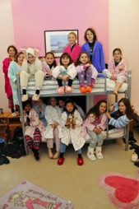
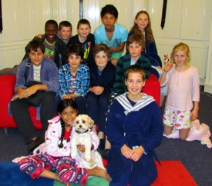

DO GET IN TOUCH WITH ANY FURTHER QUESTIONS.
OUR BOARDING PRINCIPLE
- To develop well-rounded pupils who are confident in their abilities, but respectful of their peers and willing to contribute to the school community. This will help prepare them to make the important change to senior boarding schools anywhere in the UK or beyond.

- To build and develop a warm and comfortable ethos in the boarding areas so that pupils feel safe, secure and cared-for as individuals.

Please note the last call times:

Year 7 & 8: 8.45pm
Year 5 & 6: 8.20pm
Year 3 & 4: 7.50pm
There are many different ways to communicate with your child when they are boarding. However, please do remember if they occasionally forget to call, it probably means they are having a great time in the dorms with their friends!

GIRLS’ PAYPHONE: 01473 659127
BOYS’ PAYPHONE: 01473 659405

Boarders can also use payphones during the day, email and skype and google hangout in the evenings – although this is more for Full Boarders rather than for one or two nighters!

The ringback method: so your child doesn’t need to bring 20p coins to school, they may try the famous ring-back method. They will call you and let it ring, when you pick up and hear nothing, dial 1471 and it will dial the number straight back!
COMMUNICATION
It is of paramount importance to us that your children get enough sleep, to support their health, to support a very busy day, and to give strength during stressful times such as school exams. The design and layout of the Dorms reflects this, as does the role of Dorm Captains. Adhering to the bedtime routine, including reading, helps establish regular sleep patterns, and the children learn consideration for others by not moving around or making a noise early in the morning.
ORWELL PARK SCHOOL
PARENTS’ GUIDE TO BOARDING
SLEEP! SLEEP! SLEEP!

